* Install Vagrant 1.9.0
* Install Virtual Box 5.1.26
* Install GIT
* Create a New Folder anywhere you wish.
* Inside it Right Click and Click on Open GitBash Here
* Inside the terminal type following commands

vagrant init ubuntu/trusty64

* Now in the Newfolder created you will see a file named Vagrantfile
* Open the file with notepad ++
* Add the following line after 15th line

config.vm.network "forwarded_port" , guest: 80, host:8089

* Save the file and now in the git terminal window type the following commands

vagrant up

* It takes some time and after it is done use the following command

vagrant ssh

* Now you are logged in in the Virtual machine created.
* To exit out of the vm us

exit (inside vm)

* You can shoutdown the VM using

vagrant halt

* Now To install LAMP
* 1. Install Apache
* **Apache** is an open-source multi-platform web server. It provides a full range of web server features including CGI, SSL and virtual domains.
* To install Apache, enter:
* sudo apt-get install apache2
* root@ubuntu:~# systemctl    status  apache2
* ● apache2.service - LSB: Apache2 web server
* Loaded: loaded (/etc/init.d/apache2; bad; vendor preset: enabled)
* Active: active (running) since Wed 2016-03-02 09:23:37 PST; 1min 2s ago
* Docs: man:systemd-sysv-generator(8)
* CGroup: /system.slice/apache2.service
* ├─22328 /usr/sbin/apache2 -k start
* ├─22331 /usr/sbin/apache2 -k start
* └─22332 /usr/sbin/apache2 -k start
* Mar 02 09:23:36 ubuntu systemd[1]: Starting LSB: Apache2 web server...
* Mar 02 09:23:36 ubuntu apache2[22304]:  * Starting web server apache2
* Mar 02 09:23:36 ubuntu apache2[22304]: AH00558: apache2: Could not reliably determine the server's fully qualified domain name, using 127.0.1.1. Set the 'S
* Mar 02 09:23:37 ubuntu apache2[22304]:  *
* Mar 02 09:23:37 ubuntu systemd[1]: Started LSB: Apache2 web server.
* Mar 02 09:24:34 ubuntu systemd[1]: Started LSB: Apache2 web server.
* Test Apache:
* Open your host(Windows) web browser and navigate to **http://localhost:8089/** or <http://server-ip-address:8089/>.
* 2. Install MySQL
* **MySQL** is a relational database management system (RDBMS) that runs as a server providing multi-user access to a number of databases, though SQLite probably has more total embedded deployments
* sudo apt-get install mysql-server mysql-client
* During installation, you’ll be asked to setup the MySQL “root” user password. Enter the password and click Ok.
* [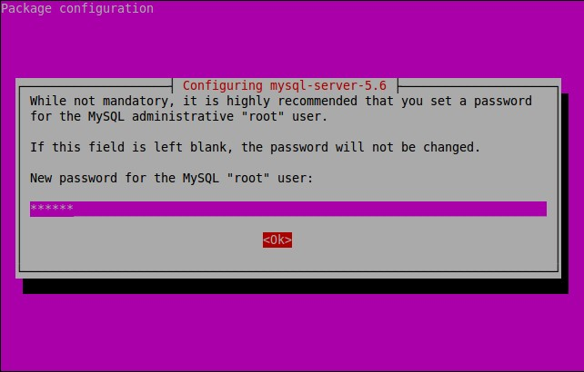](https://www.unixmen.com/wp-content/uploads/2015/10/sk@server-_0012.jpg)
* Re-enter the password.
* [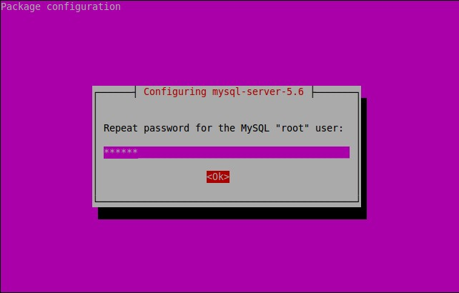](https://www.unixmen.com/wp-content/uploads/2015/10/sk@server-_0022.jpg)
* MySQL is installed now.
* You can verify the MySQL server status using command:
* **On Ubuntu 16.04/15.10/15.04:**
* sudo systemctl status mysql
* **On Ubuntu 14.10 and previous versions:**
* sudo service mysql status
* Sample output:
* mysql.service - MySQL Community Server
* Loaded: loaded (/lib/systemd/system/mysql.service; enabled; vendor preset: enabled)
* Active: active (running) since Mon 2015-10-26 14:23:01 IST; 28s ago
* Main PID: 3577 (mysqld_safe)
* CGroup: /system.slice/mysql.service
* ├─3577 /bin/sh /usr/bin/mysqld_safe
* └─3924 /usr/sbin/mysqld --basedir=/usr --datadir=/var/lib/mysql --...
* Oct 26 14:23:00 server systemd[1]: Starting MySQL Community Server...
* Oct 26 14:23:00 server mysqld_safe[3577]: 151026 14:23:00 mysqld_safe Can't ....
* Oct 26 14:23:00 server mysqld_safe[3577]: 151026 14:23:00 mysqld_safe Loggin....
* Oct 26 14:23:01 server mysqld_safe[3577]: 151026 14:23:01 mysqld_safe Starti...l
* Oct 26 14:23:01 server systemd[1]: Started MySQL Community Server.
* Hint: Some lines were ellipsized, use -l to show in full.

### 4. Install PHP  (PHP7)

**PHP** (recursive acronym for PHP: Hypertext Preprocessor) is a widely used open-source general purpose scripting language that is especially suited for web development and can be embedded into HTML.

Install PHP with following command:

sudo apt-get update

sudo apt-get install php7.0-mysql php7.0-curl php7.0-json php7.0-cgi  php7.0 libapache2-mod-php7.0

Test  your php version

root@ubuntu:~# php -v

PHP 7.0.3-3 (cli) ( NTS )

Copyright (c) 1997-2016 The PHP Group

Zend Engine v3.0.0, Copyright (c) 1998-2016 Zend Technologies

    with Zend OPcache v7.0.6-dev, Copyright (c) 1999-2016, by Zend Technologies

root@ubuntu:~#

To test PHP, create a sample “testphp.php” file in Apache document root folder.

sudo vi /var/www/html/testphp.php

Add the following lines:

<?php

phpinfo();

?>

Restart apache2 service.

On Ubuntu 15.10/15.04:

sudo systemctl restart apache2

On Ubuntu 14.10 and lower versions:

sudo service apache2 restart

Navigate to **http://server-ip-address:8089/testphp.php**. It will display all the details about php such as version, build date and commands etc.

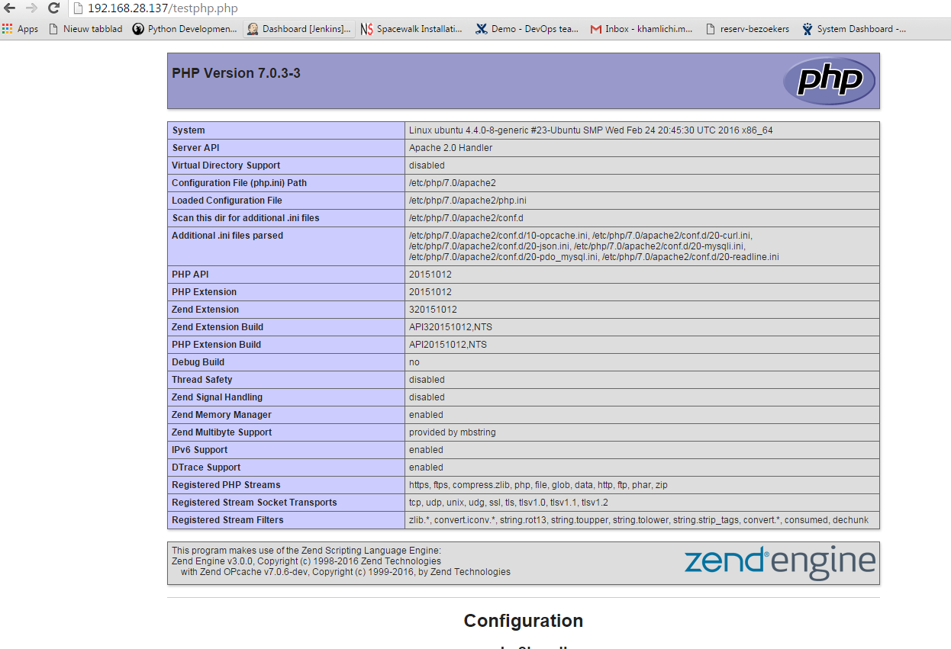

If you want to install all php modules at once, enter the command **sudo apt-get install php\*** and restart the apache2 service. To verify the modules, open web browser and navigate to **http://server-ip-address/testphp.php**. You will able to see all installed php modules.

### 5. Manage MySQL Databases (Optional)

##### Install phpMyAdmin

**phpMyAdmin** is a free open-source web interface tool used to manage your MySQL databases. It is available in the Official Debian repositories. So install it with command:

sudo apt-get install phpmyadmin

Select the Web server that should be automatically configured to run phpMyAdmin. In my case, it is apache2.

[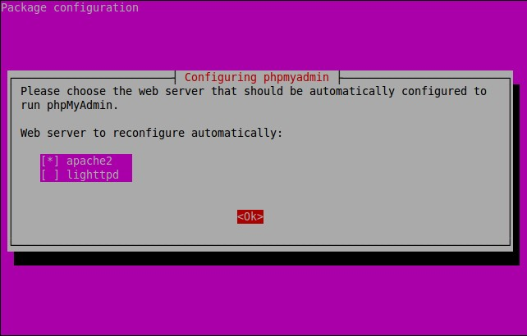](https://www.unixmen.com/wp-content/uploads/2015/10/sk@server-_004.jpg)

The phpMyAdmin must have a database installed and configured before it can be used. This can be optionally handled by dbconfig-common.

Select ‘Yes’ to configure database for phpmyadmin wjth dbconfig-common.

[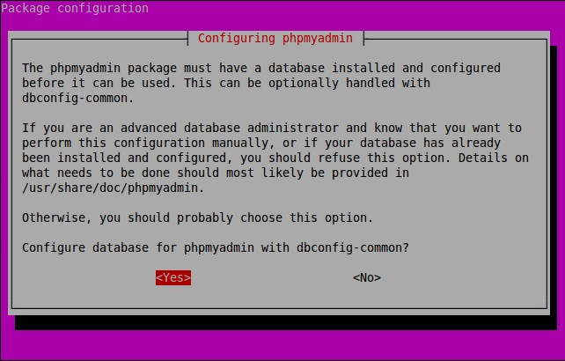](https://www.unixmen.com/wp-content/uploads/2015/10/sk@server-_005.jpg)

Enter password of the database’s administrative user.

[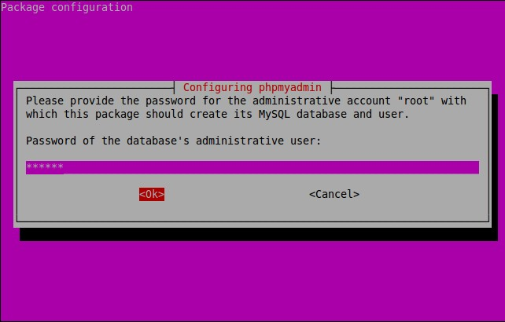](https://www.unixmen.com/wp-content/uploads/2015/10/sk@server-_008.jpg)

Enter MySQL application password for phpmyadmin:

[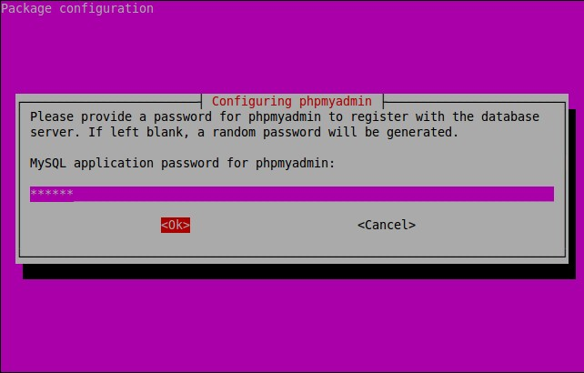](https://www.unixmen.com/wp-content/uploads/2015/10/sk@server-_006.jpg)

Re-enter password:

[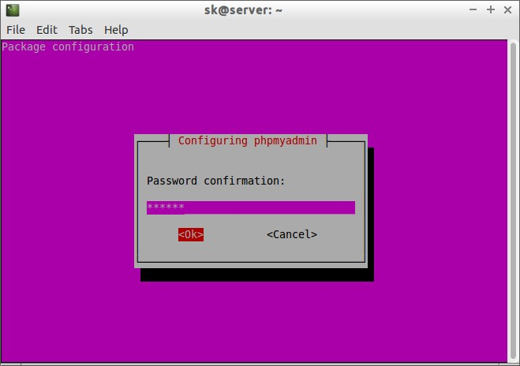](https://www.unixmen.com/wp-content/uploads/2015/04/sk@server-_009.jpg)

Success! phpMyAdmin installation is installed.

**Additional Note:** if you followed all steps carefully, phpMyAdmin should work just fine. In case phpMyAdmin is not working, please do the following steps.

Open terminal, and type:

sudo nano /etc/apache2/apache2.conf

Add the following line at the end.

Include /etc/phpmyadmin/apache.conf

Save and Exit. Restart apache service:

**On Ubuntu 16.04/15.10/15.04:**

sudo systemctl restart apache2

**On Ubuntu 14.10 and lower versions:**

sudo /etc/init.d/apache2 restart

### 6. Access phpMyAdmin Web Console

Now, you can access the phpmyadmin console by navigating to **http://server-ip-address:8089/phpmyadmin/** from your browser.

Enter your MySQL username and password which you have given in previous steps. In my case its “root” and “ubuntu”.

[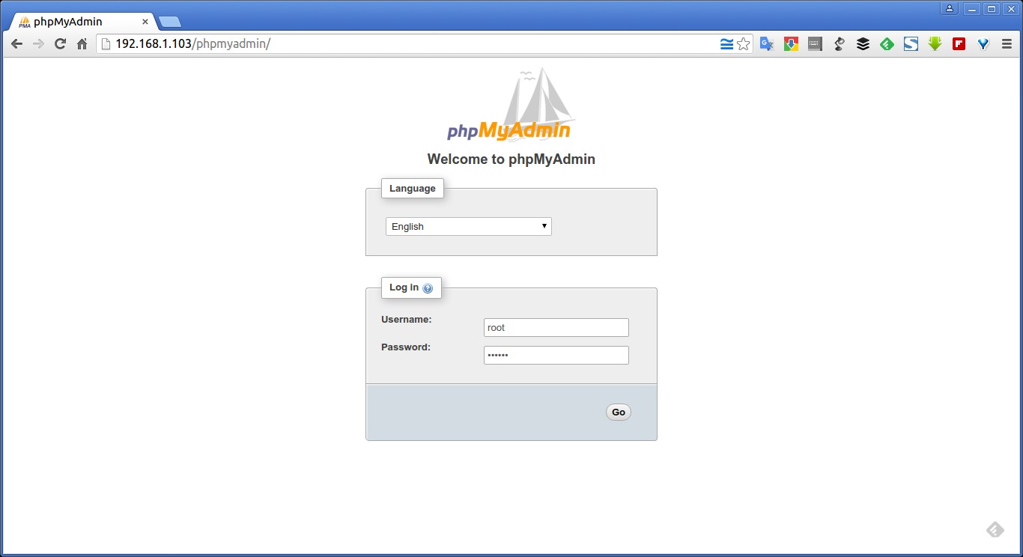](https://www.unixmen.com/wp-content/uploads/2015/10/phpMyAdmin-Google-Chrome_009.jpg)

You will be redirected to PhpMyAdmin main web interface.

[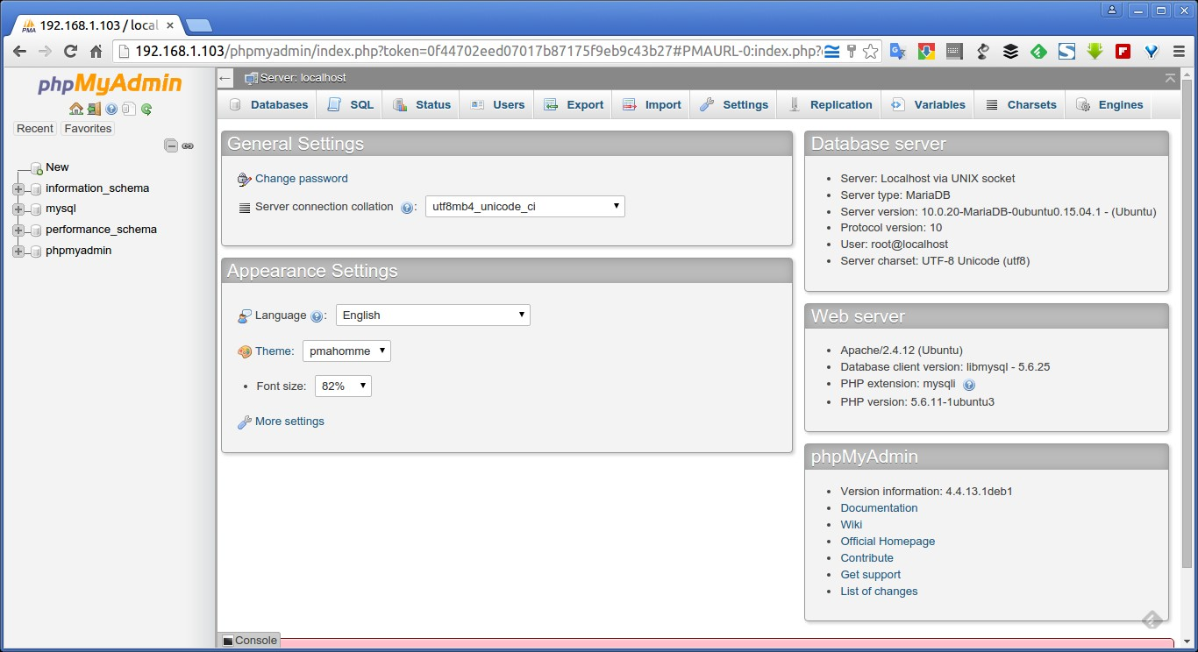](https://www.unixmen.com/wp-content/uploads/2015/10/192.168.1.103-localhost-phpMyAdmin-4.4.13.1deb1-Google-Chrome_010.jpg)

From here, you can manage your MySQL databases from phpMyAdmin web interface.

That’s it. Your LAMP stack is ready to use.